**Introduction to Octave**

GNU Octave is a high-level language, primarily intended for numerical computations. It is typically used for such problems as solving linear and nonlinear equations, numerical linear algebra, statistical analysis, and for performing other numerical experiments. It may also be used as a batch-oriented language for automated data processing. It provides a convenient command line interface for solving linear and nonlinear problems numerically, and for performing other numerical experiments. It may also be used as a batch-oriented language. Octave is often viewed as a system for numerical computations with a language that is mostly compatible with MATLAB, but that is available as free software under the GNU GPL, and that can replace it in many circumstances.

**Basic Instructions in Octaves**

**1. T = 0: 1:10**

This instruction indicates a vector T which as initial value 0 and final value 10 with an increment of 1

Therefore T = [0 1 2 3 4 5 6 7 8 9 10]

**2. T= 0:1/pi: 1**

Therefore T= [0, 0.3183, 0.6366, 0.9549]

**3. zeros (1, 3)**

The above instruction creates a vector of one row and three columns whose values are zero

Output= [0 0 0]

**4. zeros( 2,4)**

Output = 0 0 0 0

0 0 0 0

**5. ones (5,2)**

The above instruction creates a vector of five rows and two columns

Output = 1 1

1 1

1 1

1 1

1 1

**6. plot (t, x)**

If x = [6 7 8 9] t = [1 2 3 4]

This instruction will display a figure window which indicates the plot of x versus t .

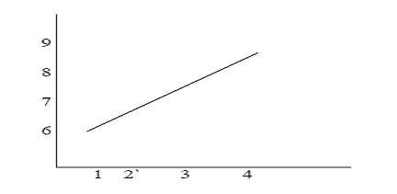

**7. stem (t,x)**  This instruction will display a figure window as shown

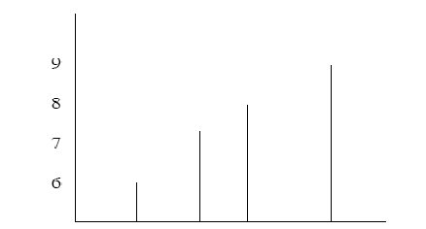

**8. Subplot:** This function divides the figure window into rows and columns.

Subplot (2 2 1) divides the figure window into 2 rows and 2 columns 1 represent number of the figure

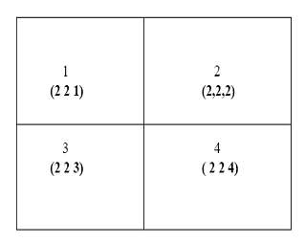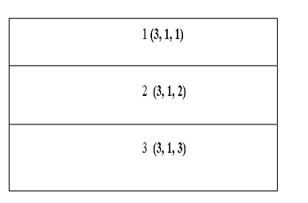

Subplot (3 1 2) divides the figure window into 3 rows and 1 column 2 represent number of the figure

**9. Conv**

Syntax: w = conv(u,v)

Description: w = conv(u,v) convolves vectors u and v. Algebraically, convolution is the same operation as multiplying the polynomials whose coefficients are the elements of u and v.

**10.Disp**

Syntax: disp(X)

Description: disp(X) displays an array, without printing the array name. If X contains a text string, the string is displayed. Another way to display an array on the screen is to type its name, but this prints a leading "X=," which is not always desirable. Note that disp does not display empty arrays.

**11.xlabel**

Syntax: xlabel('string')

Description: xlabel('string') labels the x-axis of the current axes.

**12. ylabel**

Syntax : ylabel('string')

Description: ylabel('string') labels the y-axis of the current axes.

**13.Title**

Syntax : title('string')

Description: title('string') outputs the string at the top and in the center of the current axes.

**14.grid on**

Syntax : grid on

Description: grid on adds major grid lines to the current axes.

**15. ABS** Absolute value.

ABS(X) is the absolute value of the elements of X. When X is complex, ABS(X) is the complex modulus (magnitude) of the elements of X.

**16. ANGLE** Phase angle.

ANGLE(H) returns the phase angles, in radians, of a matrix with complex elements.

**DOWNLOADING OF PACKAGES**

After opening the Octave, the most important thing is to download and install and load the Packages. Follow the steps to download and load Packages.

1. You can download the required packages from the internet (octave sourceforge site)
2. Generally required packages for signal analysis are **“Signal”,”Symbolic”**
3. After Downloading the package, now go to back to GNU OCTAVE window and in the File Browser go to place where you have Downloaded your Package
4. Now in the Command Window, type the following Command

pkg<space> install <space><package name which you downloaded with extension>

1. Now wait till the Package installs. It may take sometime about 5-10 minutes.
2. By following the above steps you can install any package.

**LOADING OF PACKAGES:**

After installing package it is very important to load the package.

* Every time you open the GNU OCTAVE you need to load the required packages for the program in the command window.
* In the command window type the following command and click enter

pkg<space> load <space><package name>

**PROCEDURE:**

* Open GNU OCTAVE
* Open new M-file
* Type the program
* Save in current directory with .m extention
* Load the packages symbolic and signal .
* For loading packages use **pkg load symbolic** and **pkg load signal** in command window.
* Compile and Run the program.
* **For the output see command window\ Figure window**
* NOTE:
* YOU NEED TO LOAD THE PACKAGES REQUIRED FOR YOUR PROGRAM EVERY TIME WHEN YOU OPEN THE OCTAVE BEFORE RUNNING THE PROGRAM.